Step For deployment:

**WebApp creation:**

1. Open Azure portal.
2. Click on App service.

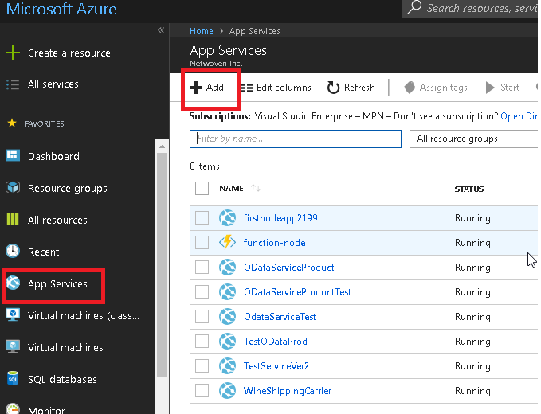

1. Create web app (Node js empty web app)

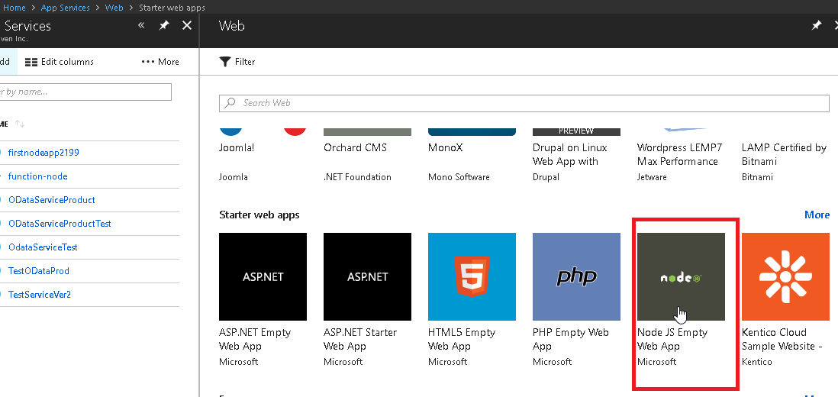

1. Provide a name and select other field value.

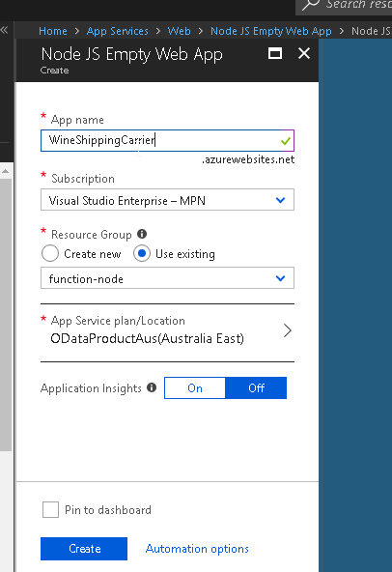

1. Click on “Create” button.

**Update Node Version:**

1. Searech for “Advance Tools” in the newly created app service. And click on “GO”

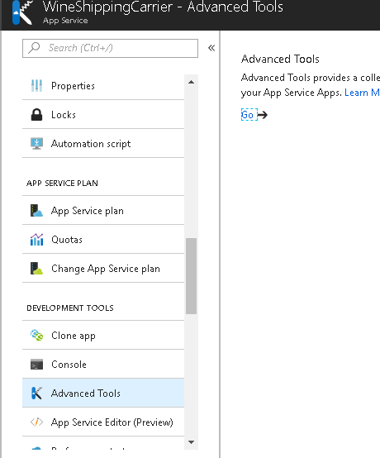

1. Go to “Debug Console” and click on the CMD.

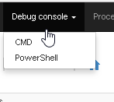

1. Go to “wwwroot” folder.

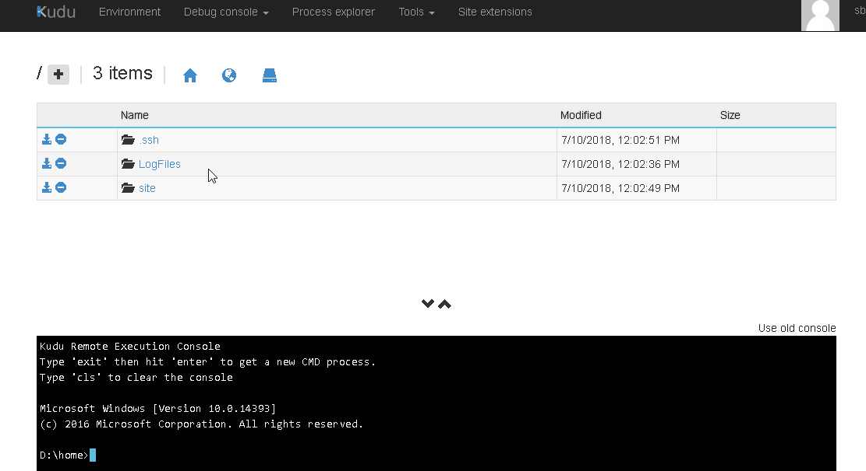

1. Edit Package json.

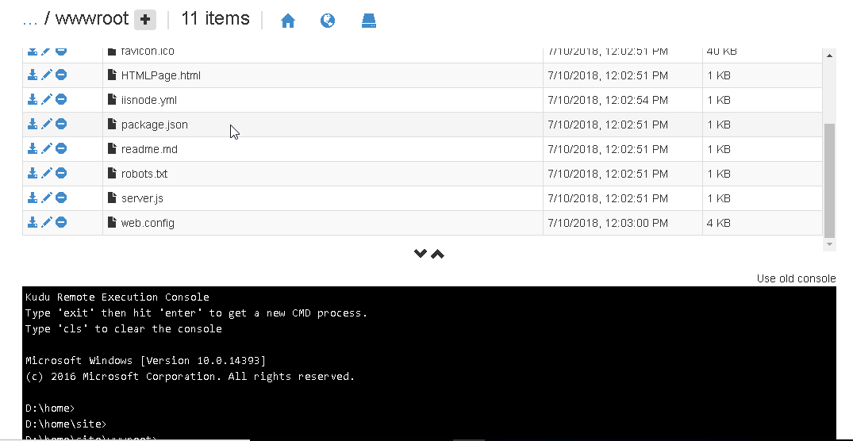

1. Change the version of node to “8.9.4”

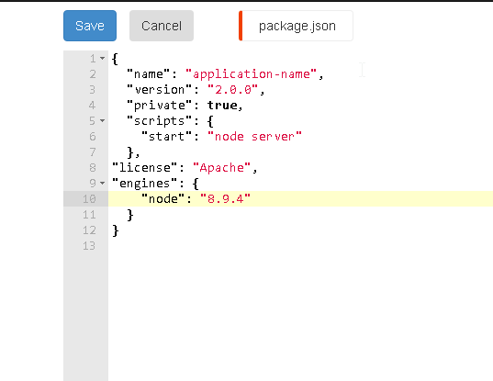

1. Go to newly created webapp. And add the following key into the “Application Settings”

WEBSITE_NODE_DEFAULT_VERSION: 8.9.4

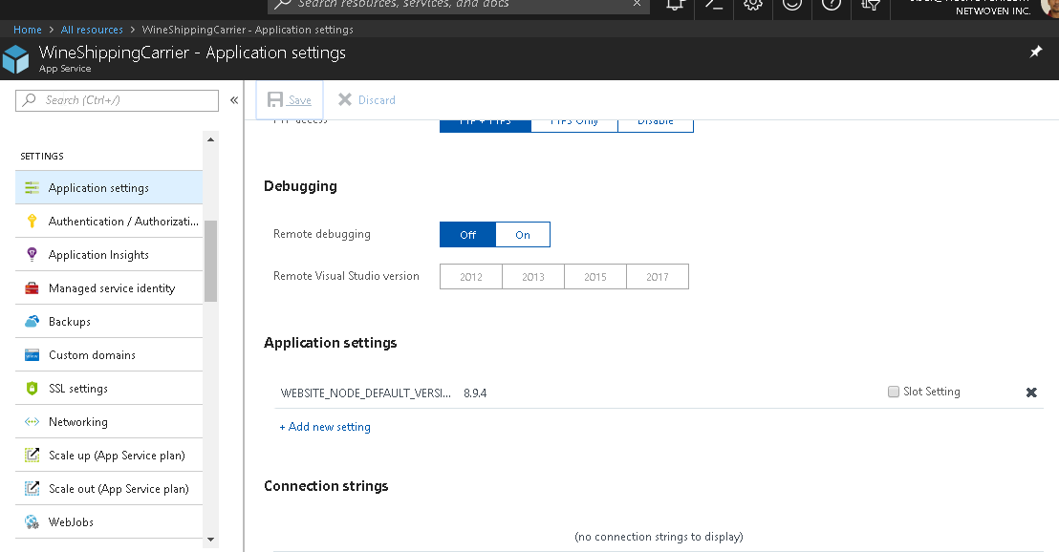

1. Verify the node vertion.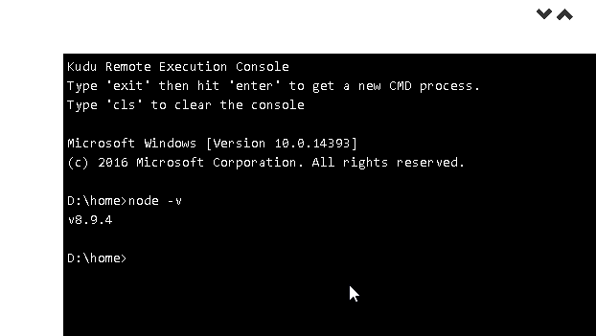

**Deploy the code.**

1. Now open the Webjobs.

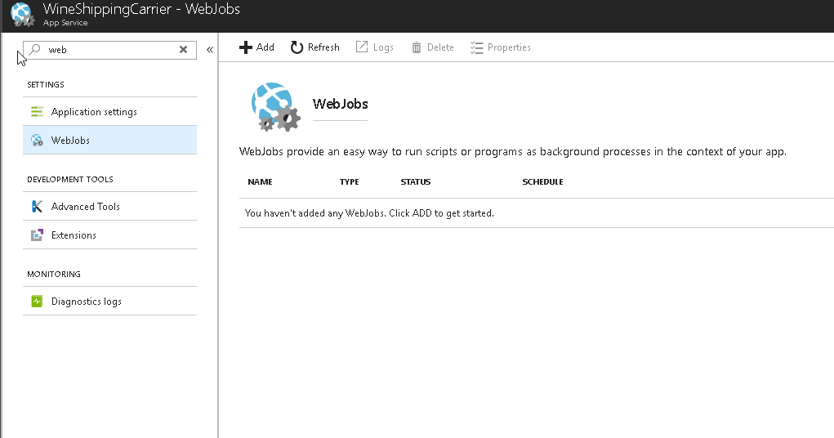

1. Upload the ZIP file of code.
2. Select the Type.
3. Click on “OK” button.

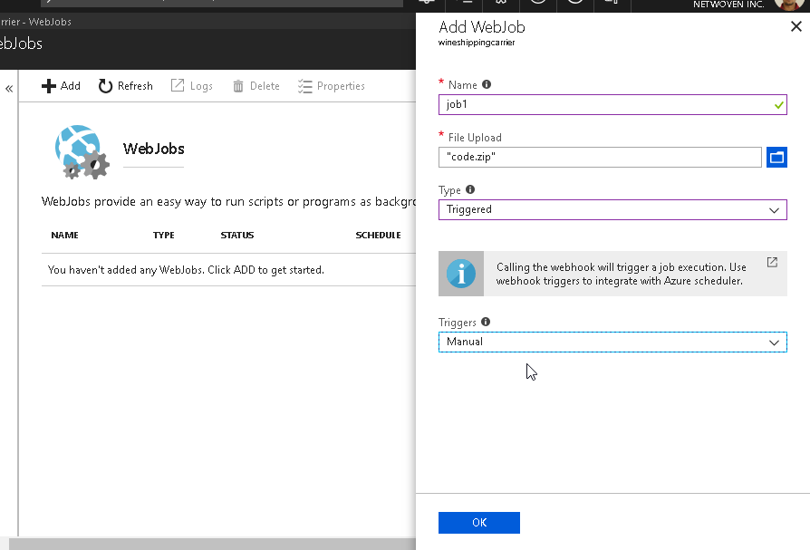

1. Click on refresh button.

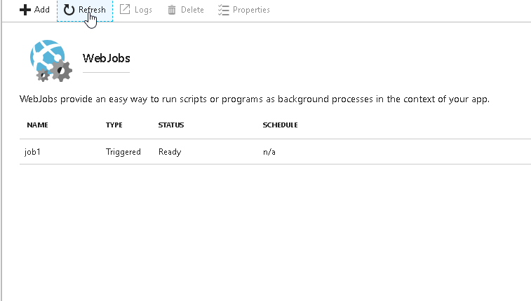

1. Now go to the CMD

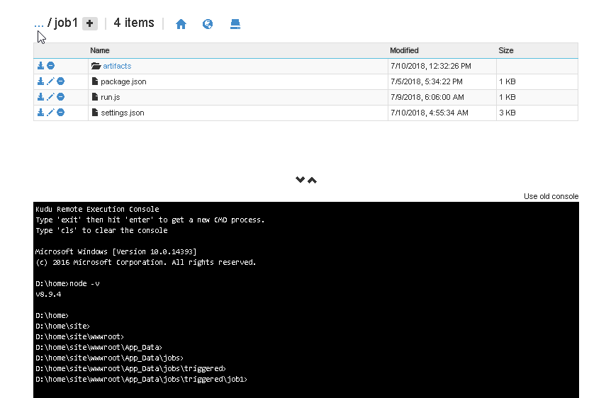

1. Go to the job folder.

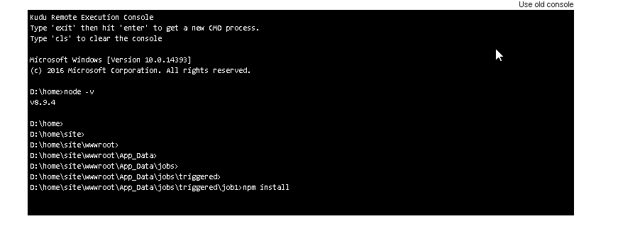

1. Run the command “npm Install”

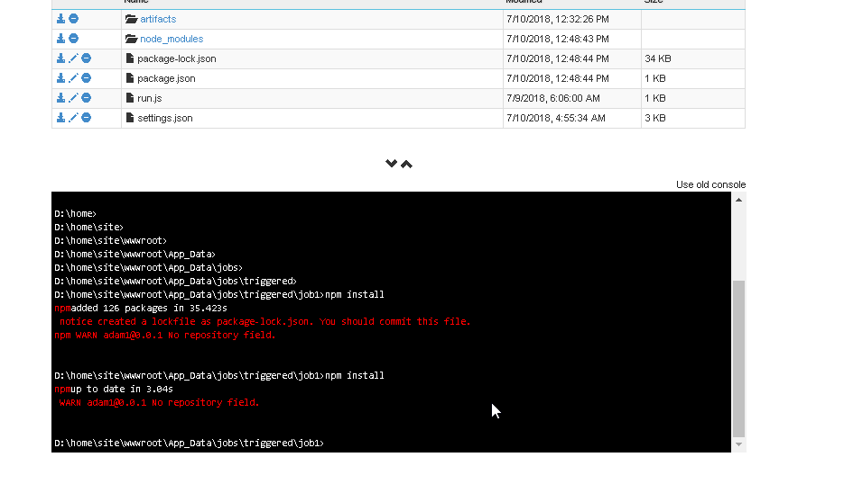

1. After successfully completion of the command webjob is ready to go.

